SEAN GLAZE
SHORT BIO

Sean Glaze is an author and leadership expert who has worked with clients like Cisco, John Deere, Coca-Cola, and Emory University to increase collaboration, boost productivity, and build exceptional workplace cultures.

As a successful basketball coach and educator for over 20 years, Sean gained valuable insights into leading winning teams – and now he travels around the country to share those lessons...

Sean’s engaging conference keynotes and interactive team building events help accelerate the growth of more effective leaders.

And Sean’s books, Rapid Teamwork, The 10 Commandments of Winning Teammates, and Staying Coachable are entertaining parables with powerful take-aways to improve team performance and leadership!

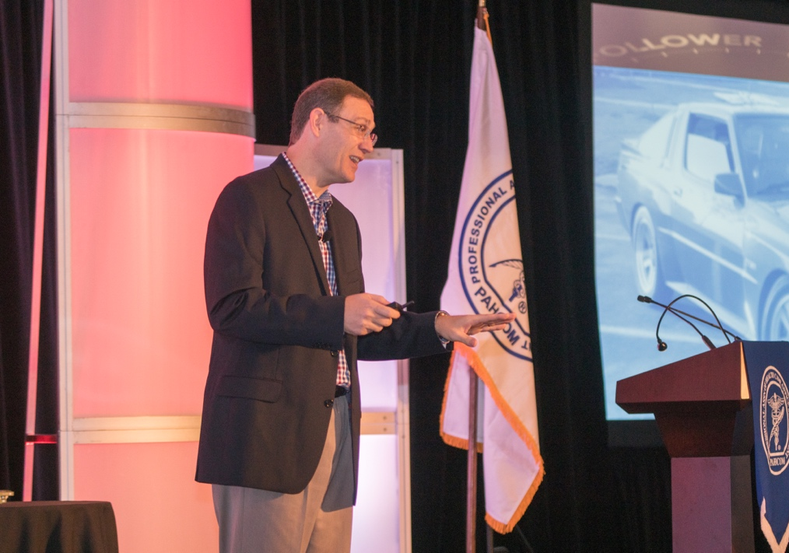

SEAN GLAZE
WEBSITE AND SOCIAL MEDIA LINKS

EFFECTIVE LEADERS WEBSITE
https://effectiveleaders.live/

GREAT RESULTS TEAMBUILDING WEBSITE
https://greatresultsteambuilding.net/

LINKEDIN
https://www.linkedin.com/in/seanglaze

TWITTER
https://twitter.com/leadyourteam

TIKTOK
https://www.tiktok.com/@leadyourteam

FACEBOOK
https://www.facebook.com/GreatResultsTeambuilding?sk=wall

YOUTUBE
https://www.youtube.com/c/SeanGlaze

WHERE AUDIENCE CAN GRAB SEAN’S FREE RESOURCES -

GET FREE ACCESS TO SEAN’S TEAM LEADERSHIP TOOLBOX,
WITH OVER 50 USEFUL HANDOUTS & ACTIVITIES TO
CREATE A MORE POSITIVE AND PRODUCTIVE CULTURE!

VISIT - WWW.TOOLBOXSTUFF.COM

SEAN GLAZE
AV REQUIREMENTS

For the best audience experience, Sean will run his program using his own MacBook (with embedded audio, video, and interactions) placed on a podium set to the far right or left side of the stage.

He requires the ability to advance his own slides with his handheld remote, and will meet at the earliest convenience of you’re a/v personnel on the event date to ensure an ideal experience.

Sean prefers a wireless lapel or headset mic., and requires a digital projector with a large screen for his program slide images and interactive polling. For audiences greater than 400 people, IMAG (image magnification) is highly recommended.

A raised stage platform is ideal for large audiences to ensure that all attendees have an unobstructed view of the program.

A brightly lit stage with a dark backdrop is best for audiences to maintain focus on the front of the room. Sean will utilize the entire stage and may even walk into the audience at times.

A repeater monitor (for power point) at front of stage is helpful.

Sean also requests and login access to the A/V Wi-Fi.

- - - - -

(Sean can accommodate his program to most any environment
or room and is easy to work with – please reach out if there are any questions or issues regarding room setup or a/v needs)

