FIVE CRUCIAL QUESTIONS FOR LEADERS TO BUILD AN EXCEPTIONAL TEAM CULTURE
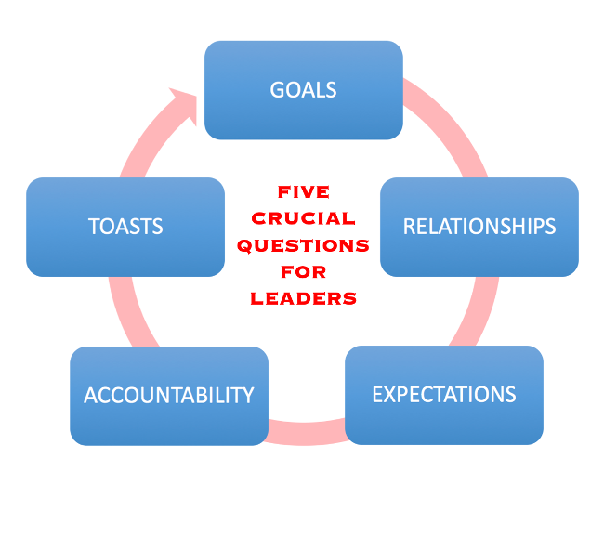
Leadership is about far more than defining strategy...
The most successful managers and leaders have discovered that while strategy is about what you want to get done, it is WORKPLACE CULTURE that determines how well your people will execute on those plans.
But understanding that team leadership involves building and sustaining a more positive culture is just the first step.

The issue often lies in learning HOW to do that.
What steps are required?

What weekly actions can be taken to build and sustain an environment where people can thrive and develop and perform well together?
That is the value of having crucial questions that you can ask yourself as a leader to ensure that you are addressing the necessary elements that contribute to a healthy culture.
And to build or sustain a GREAT team culture as a leader, you need to focus on five areas.
(Goals, Relationships, Expectations, Accountability, and Thanks)

In one of my earliest teamwork books, the main character learns about these five parts of a positive workplace culture while on a rafting trip with his management team.
If you want to begin to improve yourself as a team leader, and begin to build a more positive and profitable team culture, these are the five crucial questions you will need to consider:

1 Why are we here, & what will success look like?
(this questions is focused on clarifying your mission and goals)

2 What should I know about you?
(this questions is focused strengthening connections and relationships)

3 How will we best work together?
(this questions is focused on defining standards and expectations)

4 How will we adjust and address issues?
(this questions is focused on providing feedback and accountability)

5 How will we celebrate our efforts?
(this questions is focused on explaining your plan for recognition and thanks)

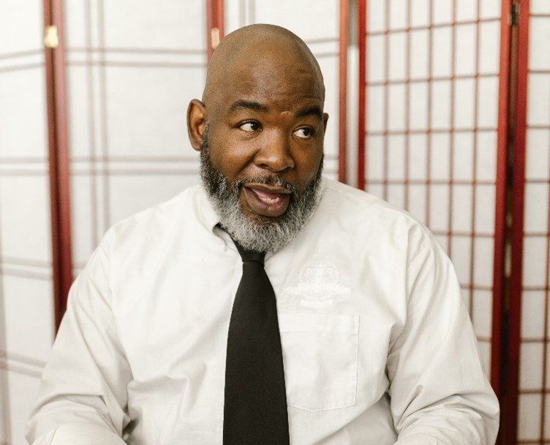
Each of these questions is a vital part of establishing a workplace culture where your people can enjoy more positivity and productivity.
Some of the questions you may be very comfortable answering.
But there is likely one or more you haven’t considered.

It is the questions you neglect that sabotage your productivity.
Obviously, there is much that will need to be considered when answering each of these questions – but the key is to begin to work through and improve your answers…
Ask your team for their input on the questions.
And then SHARE the answers you settle on with your team.

The best leaders communicate more often than their unsuccessful competitors.
The best leaders understand that being unclear is being unkind.
The best leaders have a process and system for sustaining a positive culture.
The best leaders refuse to neglect items that could diminish team performance.

And while training programs, corporate teambuilding, mentoring, and conference leadership keynotes can contribute to your development as a leader, GREAT leadership requires a specific focus.
Doing what need to is FAR more effective than only doing what you know to…
Once you become more aware of what is needed to lead your people effectively, you become more able to do what is needed.

Awareness is a key component of growth for leaders.
Effective leadership begins with asking these five crucial questions.

SEAN’S SHORT BIO

Sean Glaze is a speaker and author who works with organizations to develop Effective Leaders and Winning Teammates.

His programs and books have helped clients like Cisco, John Deere, and Emory University to increase team collaboration, boost productivity, and build more positive and profitable workplace cultures.

You can learn more about Sean on his website:
https://greatresultsteambuilding.net/team-building-speaker/

Or connect with him on LinkedIn at:
https://www.linkedin.com/in/seanglaze/

