HOW TO RETAIN TALENT AND REDUCE TURNOVER WITH LOYALTY ANCHORS

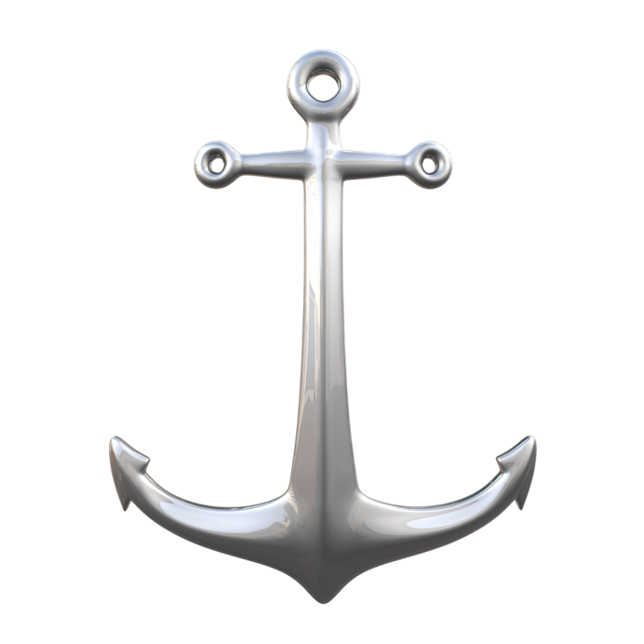

I love the term “LOYALTY ANCHORS.”
Anchors are what keep expensive ships from floating away when the winds change.
And as a business owner or manager, one of your primary goals is likely to retain top talent and inspire loyalty among your employees. This not only ensures the continued success of your company, but also helps to create a positive and productive work environment.

With the constantly changing job market and the rise of the gig economy, retaining talent and inspiring loyalty to reduce turnover can be a challenge.
Sometimes one anchor alone isn’t effective.
Keeping your best ships comfortable and secure amid various storms of temptation can be difficult – but is definitely possible.

There are SIX WAYS you can achieve these goals

with LOYALTY ANCHORS:

1 – PAY
Offer competitive salaries and benefits. One of the biggest reasons employees leave their jobs is because they feel undervalued or underpaid. By offering competitive salaries and benefits, you can show your employees that you value their contributions and that you are willing to invest in their future with your company.

2 – PEOPLE
Create a positive work culture made up of quality people that others like to be around.
Building a positive workplace culture can go a long way in retaining talent and inspiring loyalty. This includes developing Winning Teammates, fostering collaboration and teamwork, and creating a respectful and inclusive environment.
By surrounding them with OTHER great people and designing opportunities and corporate team building activities, you can foster a sense of community and belonging among your employees, which can help to inspire loyalty and commitment.
3 – PURPOSE
Having a meaningful purpose and mission at work can inspire loyalty among employees. When employees understand the reason behind their work and how it fits into the larger picture, they are more likely to be motivated and committed to the success of the company.
One way to inspire loyalty through a meaningful purpose and mission is to clearly communicate the company’s values and goals. This can be done through regular meetings, company-wide presentations, and even by posting the mission statement in a prominent location in the office. By making sure that everyone is aware of the company’s purpose and direction, employees will feel more connected to the organization and more invested in its success.
4 – PARAMETERS
With the increase in remote and hybrid work situations, this is the most recent addition to the list of loyalty anchors. Clear expectations and boundaries for work-life balance can inspire loyalty at work. When employees understand what is expected of them in terms of their work and personal time, they are more likely to be motivated and committed to the success of the company.
One way to inspire loyalty through clear expectations and boundaries is to establish synchronous and asynchronous working hours and communicate them clearly to employees, so they know when they are expected to respond, when they are able to work without interruption, and when they are not expected to involve themselves with work.
You can also encourage employees to take time off when needed. By giving employees the freedom and support to take care of themselves and their personal lives, companies can foster a sense of trust and loyalty
5 – PROGRESS
Provide opportunities for growth and development. Another key factor in retaining talent is providing opportunities for growth and development. This could include training programs, leadership development courses, or mentorship programs. By giving your employees the tools and support they need to grow their skills and advance in their careers, you can inspire loyalty and keep them engaged and motivated.
6 – PRAISE
Recognize and reward employees for their contributions. Recognition and rewards are important for retaining talent and inspiring loyalty. This could include public recognition for a job well done, performance-based bonuses, or other rewards that show your appreciation for your employees’ hard work and dedication.
People want desperately to feel SEEN and have their effort noticed. By recognizing and rewarding employees for their contributions, you can show them that their efforts are valued and that you are committed to their success.

If you want to attract and retain top talent, your most important job as a leader is to help create and sustain an exceptional workplace culture.
The environment you create or allow is a huge determiner in who wants to stay. Your most talented and desirable people will always have the most options available to them – and if you want to inspire their loyalty and continued contributions, your commitment to a more positive and productive culture is what it will take.

SEAN’S SHORT BIO

Sean Glaze is a speaker and author who works with organizations to develop Effective Leaders and Winning Teammates.

His programs and books have helped clients like Cisco, John Deere, and Emory University to increase team collaboration, boost productivity, and build more positive and profitable workplace cultures.

You can learn more about Sean on his website:
https://greatresultsteambuilding.net/team-building-speaker/

Or connect with him on LinkedIn at:
https://www.linkedin.com/in/seanglaze/

