AN “INTERACTION MATRIX”
FOR EFFECTIVE LEADERS

Leadership occurs one conversation at a time.

Effective communication lies at the heart of successful leadership.

As a manager or team leader, your ability to connect with and inspire your team members can have a profound impact on their beliefs, behaviors, and overall performance.

Recognizing that leadership occurs one interaction at a time, it is crucial to consider the kind of interactions you want to have with each team member, ensuring a positive impact on their professional growth.

Consideration is about fostering Appreciation and Openness

Being considerate in your communication is essential for cultivating an environment where your team members feel appreciated rather than defensive. It involves choosing your words carefully, showing empathy, and demonstrating genuine interest in their perspectives. Consideration allows you to build trust, strengthen relationships, and encourage open dialogue within your team. By adopting a considerate approach, you can create an atmosphere that promotes collaboration and nurtures a sense of belonging among your team members.

Compelling Influence is about Inspiring Action and Accountability

In addition to being considerate, it is equally important for leaders to be compelling in their communication. Compelling communication involves delivering messages that inspire action and motivate team members to embrace new ideas or strategies. Your words should convey a sense of purpose, highlight the importance of the task at hand, and ignite a desire to excel. By crafting compelling messages, you can instill a shared vision within your team, increase engagement, and drive performance.

As a leader, you will want to consider the kind of interactions you want to have with each of your team members to ensure the most positive impact on their behaviors.

Everything you have said or will say can be placed in one of the quadrants below…

And the quality of your team interactions – the measure of effective leaders – will be based on two things

EVERYTHING YOU HAVE SAID OR WILL SAY AFFECTS YOUR TEAM BASED ON TWO THINGS –

1. HOW CONSIDERATE YOUR WORDS ARE
2. HOW COMPELLING YOUR WORDS ARE

Being considerate is important to ensure that your people accept your message as kind and thoughtful s they feel valued and appreciated rather than defensive.

Being compelling is important to ensure that your people understand the importance of taking action on the information you have shared.

Understanding the Quadrants:

To further enhance your communication effectiveness, it can be helpful to analyze your interactions based on the consideration and compelling factors. Visualize these factors as two axes, forming four quadrants:

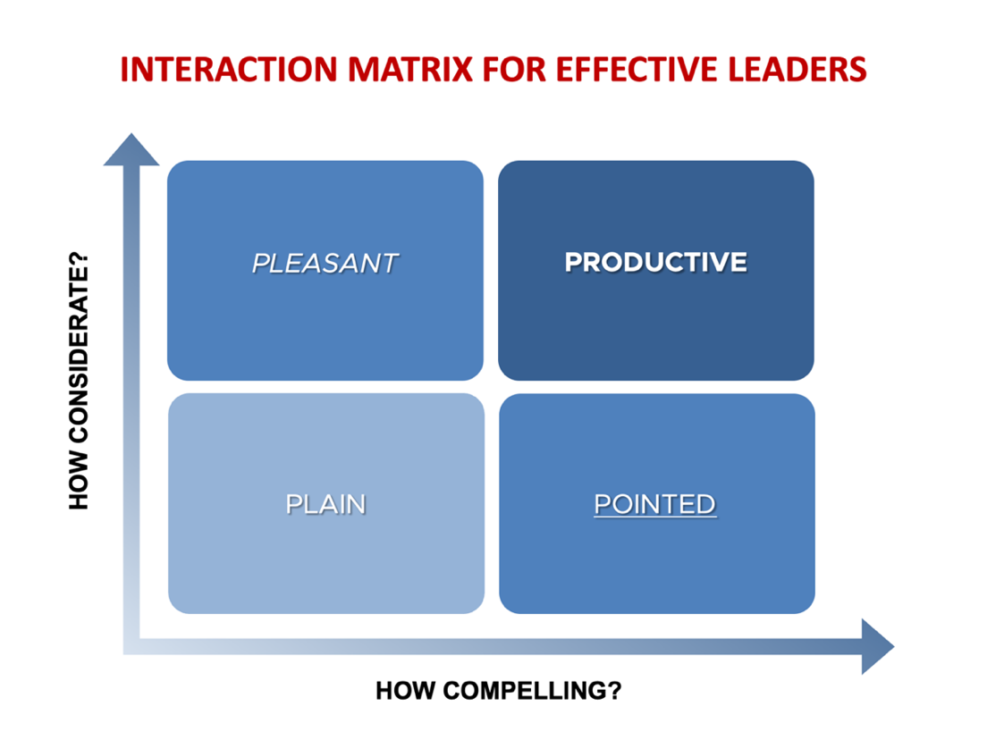

QUADRANT 1 – PLAIN
Less Considerate and Less Compelling:

Interactions in this quadrant are ineffective and can lead to misunderstanding, resistance, or disengagement among team members. Strive to minimize your presence in this quadrant by always aiming to be both considerate and compelling in your communication.

THIS IS THE INNOCUOUS COMMENT YO SHARE WITHOUT PREPARATION OR ANY REAL INTENTION OF IMPACTING THEIR BEHAVIOR.

THE BENIGN “HI, HOW ARE YOU?”

THE BLAND “HAVE A GOOD DAY”

QUADRANT 2 – PLEASANT
Considerate but Less Compelling:

Interactions falling into this quadrant are characterized by kindness and thoughtfulness, but they may lack the ability to inspire immediate action. While being considerate is commendable, it is essential to find ways to make your message more compelling to encourage your team members to take the desired course of action.

THIS IS THE AREA OF COMPLIMENTS AND COMPASSION, AND IT CAN OFTEN BUILD A SENSE OF CARING AND THOUGHFULNESS WITH TEAM MEMBERS.

THE COMFORTING “HOW IS YOUR DAD DOING? I’VE BEEN THINKING ABOUT YOU BOTH”

THE CHARISMATIC “YOU ARE SO TALENTED- I’M GLAD TO HAVE YOU ON OUR TEAM”

QUADRANT 3 – POINTED
Compelling but Less Considerate:

In this quadrant, your communication might be persuasive and impactful in terms of motivating action, but it may lack consideration for the individuals involved. Remember that consideration builds rapport and fosters a sense of trust. Find ways to infuse empathy and understanding into your compelling messages to maintain positive relationships with your team.

THIS IS WHERE YOU SAY IN A STRAIGHTFORWARD OR EVEN CRITICAL WAY WHAT NEEDS TO CHANGE OR IMPROVE… AND YOU ALLOW URGENCY TO SUPERCEDE EMPATHY. (DISCOURTEOUS DEMANDS OFTEN LEAD TO DEFIANCE)

THE DIRECT “YOU NEED TO GET THAT REPORT FINISHED BY 3:00.”

THE DISAPPROVING “THAT ISN’T EVEN CLOSE TO WHAT I ASKED FOR”

QUADRANT 4 – PRODUCTIVE
Considerate and Compelling:

In this quadrant, your communication is both kind and thoughtful, while also conveying the importance of the message. Interactions in this quadrant have the potential to generate a positive impact on team members, fostering appreciation and motivation simultaneously. Strive to spend the majority of your communication in this quadrant to create an environment of trust and inspiration.

THIS IS THE AREA YOU WANT TO STRIVE FOR, WHERE COMMENTS AND INTERACTIONS ARE APPRECIATED AND ACTED ON BECAUSE YOU COMMUNICATE BOTH CARE AND IMPORTANCE.

THE UNDERSTANDING. “I KNOW HOW YOU FEEL… I FELT THE SAME WAY… AND I LEARNED THAT ____”

THE USEFUL “I NOTICED SOMETHING YESTERDAY THAT I THINK COULD BE VERY HELPFUL FOR YOU… SO WOULD YOU LIKE TO HEAR ABOUT IT?”

IT IS YOUR JOB TO SPEND THE MOST TIME IN QUADRANT FOUR…

THAT IS WHERE YOU WILL CREATE THE MOST POSITIVE IMPACT.

As a manager or team leader, becoming a better communicator is crucial for maximizing the potential of your team. By recognizing that leadership occurs one interaction at a time, you can intentionally choose the kind of interactions you have with each team member.

Balancing consideration and compelling influence allows you to create a positive impact on their beliefs and behaviors. By being considerate, you foster appreciation and openness, while being compelling ensures that your team members understand the importance of taking action.

Continuously strive to improve your communication skills, and by doing so, you will enhance your leadership capabilities and foster a high-performing team

Communicating is about being direct with expectations while being kind in your delivery.

The goal is NOT a saccharin sweetness without direction.

The goal is NOT coarse commands without gentleness.

Your goal IS to make it clear that you care about your people… and their performance.

Hiring an executive team leadership coach can help leaders to improve their awareness of how their interactions are affecting team performance.

And often a corporate team building event can help your team members appreciate the impact of their conversations with coworkers.

The key to improved team results and retention is improving your team interactions.

So – what quadrant will define YOUR comments and interactions this week?

SEAN’S SHORT BIO

Sean Glaze is a speaker and author who works with organizations to develop Effective Leaders and Winning Teammates.

His programs and books have helped clients like Cisco, John Deere, and Emory University to increase team collaboration, boost productivity, and build more positive and profitable workplace cultures.

You can learn more about Sean on his website:
https://greatresultsteambuilding.net/team-building-speaker/

Or connect with him on LinkedIn at:
https://www.linkedin.com/in/seanglaze/

