What is a Great Teammate,

and WHY Should You Choose to

Be One at Your Workplace?

As a team leader or employee, the quality of your days and the quality of your results is likely impacted significantly by the quality of your teammates.
In my book, The 10 Commandments of Winning Teammates, the main character has lost his job and is traveling to take on a new position in another town – and during the journey, he asks each of the people he talks with one very interesting question:
“Who is the best teammate you ever had?”

That question results in him validating the list of traits that his coach had shared years earlier.
But as you know, you don’t have to be an athlete to appreciate the impact of a great teammate.
As the main character learns during the story, a great teammate is someone who

- respects the clock and calendar
- shares appreciation and thanks
- is aware of and encourages others
- claims personal responsibility for results
- stays coachable
- gives clear expectations
- (and a few others you can find in the book!)

In fact, when I speak at conferences, I often have the audience contribute their thoughts about what one word describes the person they remember as a great teammate.
It is part of a live poll activity…
Here is an example of the results:
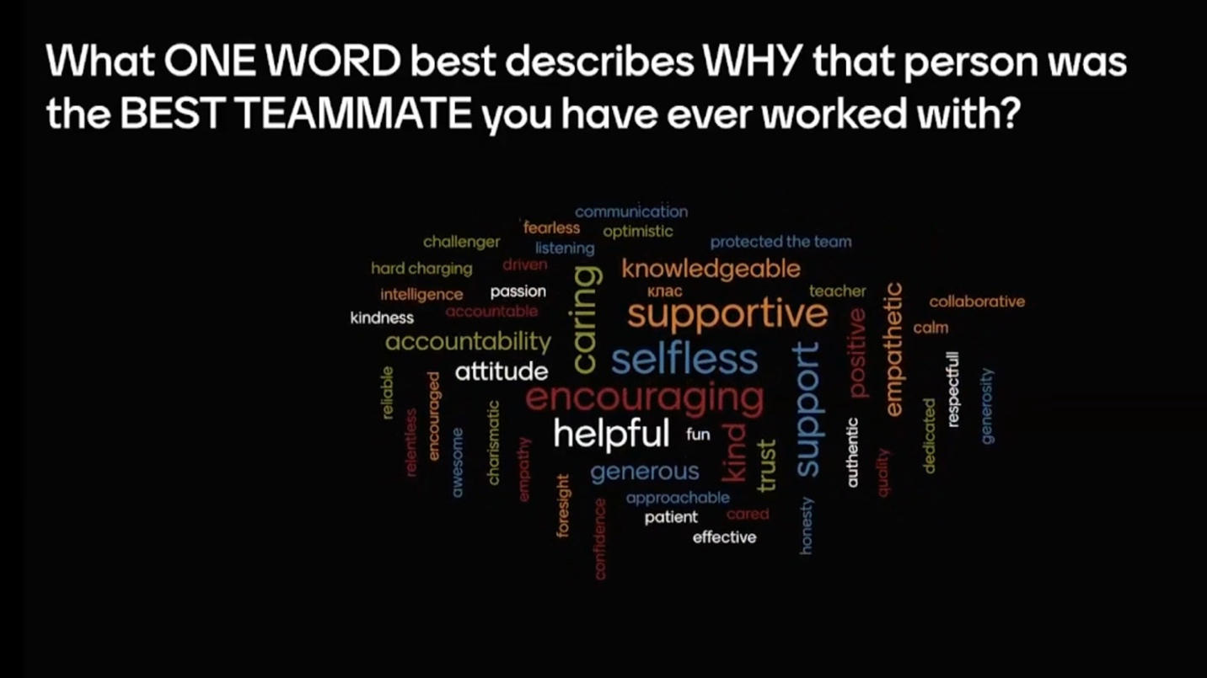

In your organizations, your team members show up each day, in-person or virtually, hoping that YOU will demonstrate those traits.
Being a great teammate is often seen as a virtue in the workplace, but did you know that there are actually unexpected benefits to being a stellar team player? Research has shown that being a great teammate can not only improve your own work performance but also have positive impacts on your colleagues and the overall team dynamic.

Here are some unexpected benefits of being a great teammate:
Increased job satisfaction and engagement
Research has consistently shown that employees who have positive relationships with their colleagues are more engaged and satisfied with their jobs. In fact, a study conducted by Gallup found that employees who have a best friend at work are seven times more likely to be engaged in their jobs. When you prioritize building strong relationships with your teammates, you not only improve your own job satisfaction but also contribute to a more positive and engaged team environment.
Improved productivity
Collaboration is key in the workplace, and when teammates work well together, productivity can increase. A study conducted by the University of Michigan found that employees who collaborated frequently and effectively were more productive than those who worked alone. When you work well with your teammates, you can leverage each other’s strengths, share ideas, and problem-solve together, leading to more efficient and effective work.
Enhanced creativity
When you work with people from different backgrounds and perspectives, you can tap into a wider range of ideas and approaches. A study conducted by the University of Texas found that diversity in a team can lead to more creative and innovative ideas. By being a great teammate and valuing the perspectives of others, you can contribute to a more creative and innovative team environment.
Increased trust
Trust is essential in any team dynamic, and being a great teammate can help build trust among colleagues. When you consistently show up for your teammates, listen to their ideas, and offer support when needed, you demonstrate that you are reliable and trustworthy. This can create a positive feedback loop, as your teammates are more likely to reciprocate the trust and support that you have shown them.
Better health and well-being
Believe it or not, being a great teammate can actually have positive impacts on your health and well-being. Research has shown that having strong social connections can improve physical and mental health outcomes. When you prioritize building positive relationships with your colleagues, you can not only improve your own well-being but also contribute to a more supportive and caring team environment.
Being a great teammate has a wide range of unexpected benefits.

Being a great teammate definitely helps your coworkers and your company succeed…

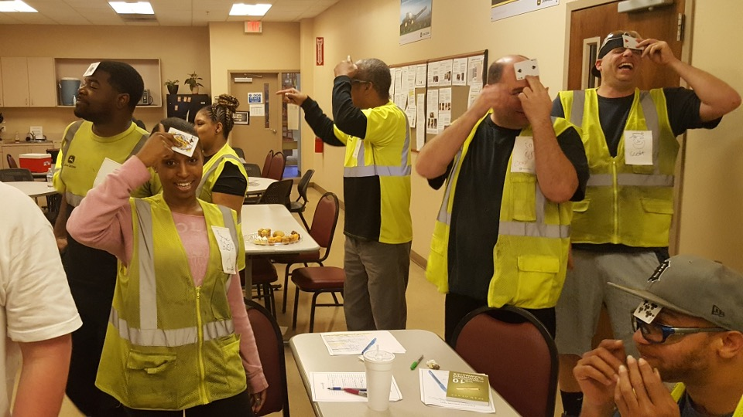

By prioritizing building positive relationships with your colleagues, you can not only improve your own job satisfaction and productivity but also contribute to a more creative, innovative, and supportive team environment.

But very little has been shared to clarify WHY YOU SHOULD BE A GREAT TEAMMATE.
Luckily, I have collected some very interesting statistics for you!
There is a growing body of research that suggests that individuals who work well with others and are reliable, supportive team members tend to perform better at work.

Great Teammates are more likely to earn more…

And here are just a few examples from recent research studies:

The study on “pro-social” behaviors and salary:
A study published in the Journal of Occupational and Organizational Psychology found that employees who exhibited “pro-social” behaviors, such as helping others and cooperating with coworkers, tended to earn higher salaries than their less helpful colleagues.
https://onlinelibrary.wiley.com/doi/abs/10.1111/joop.12268

The study on “collective intelligence” and team performance:
Another study published in the journal PLOS ONE found that teams with high levels of “collective intelligence” – a measure of how well team members work together – tended to perform better on a variety of tasks and earn higher profits.
https://journals.plos.org/plosone/article?id=10.1371/journal.pone.0095978

The report on teamwork and dependability from SHRM:
A report from the Society for Human Resource Management found that “teamwork and dependability” were among the most important factors in determining employee performance and compensation.
https://www.shrm.org/hr-today/trends-and-forecasting/research-and-surveys/Documents/2016-Employee-Job-Satisfaction-and-Engagement-Report.pdf

The survey on the importance of teamwork and collaboration by LinkedIn:
According to a survey by LinkedIn, 80% of professionals believe that teamwork and collaboration are key to success in the workplace.
https://business.linkedin.com/content/dam/business/talent-solutions/global/en_us/c/pdfs/The-Rise-of-Teamwork.pdf

The University of Michigan study on agreeableness and salaries:
A study by the University of Michigan found that employees who rated high on agreeableness were more likely to earn higher salaries than those who rated lower on this trait.
https://www.ncbi.nlm.nih.gov/pmc/articles/PMC5538346/

The Harvard Business School study on helpfulness and promotions:
A study by Harvard Business School found that employees who help their colleagues were rated as more valuable by their supervisors, leading to more promotions and higher salaries.
https://hbr.org/2015/08/helping-coworkers-feels-good-but-it-might-not-help-your-career

The Globoforce survey on recognition and turnover:
A survey by Globoforce found that companies that recognize employees for their helpfulness and collaboration have a 31% lower voluntary turnover rate than those that don’t.
https://www.globoforce.com/wp-content/uploads/2015/03/SHRM-SP-Survey-Final.pdf

The University of Exeter study on supportiveness and leadership:
A study by the University of Exeter found that employees who were supportive and helpful to their colleagues were more likely to be viewed as leaders by their peers, leading to more opportunities for career advancement.
https://www.sciencedirect.com/science/article/abs/pii/S1048984309000332

The McKinsey & Company report on teamwork and innovation:
A report by McKinsey & Company found that employees who work well in teams and support each other are more likely to be innovative and successful in their work, leading to better business outcomes and career success.
https://www.mckinsey.com/business-functions/organization/our-insights/teamwork-at-the-top-how-corporate-boards-can-help-teams-work-together

These findings suggest that being a “Winning Teammate” and a reliable, supportive employee can have a significant impact on improving team success… and your income!
Being a great teammate and actively seeking to fulfill the needs of the team not only contributes to a harmonious workplace but also enhances individual growth and overall team effectiveness.
Ultimately, the value of being a stellar teammate lies in the team's success.

When individuals put the team's needs ahead of personal agendas, a culture of collaboration and mutual respect thrives, enabling the group to navigate challenges and seize opportunities more effectively. In a thriving workplace culture, employees find satisfaction in contributing to something larger than themselves.

And the organization reaps the rewards of a high-performing, unified team.

SEAN’S SHORT BIO

Sean Glaze is a speaker and author who works with organizations to develop Effective Leaders and Winning Teammates.

His programs and books have helped clients like Cisco, John Deere, and Emory University to increase team collaboration, boost productivity, and build more positive and profitable workplace cultures.

You can learn more about Sean on his website:
https://greatresultsteambuilding.net/team-building-speaker/

Or connect with him on LinkedIn at:
https://www.linkedin.com/in/seanglaze/

