How to Build Confidence as an Effective Leader in Four Fundamental Steps

Well, if you have ever found yourself facing change, or an important decision, or responsible for a team – and felt like you were in a fog of uncertainty… You're not alone.

Confidence isn't just a nice-to-have quality; it's the fuel that drives effective leadership. The ability to inspire and motivate others stems from a deep-rooted belief in oneself and one's capabilities.

As a team leader, you are often steering a ship through uncharted territory, with your crew looking to you for direction and sureness determination. Without confidence, your decisions become hesitant, your vision remains blurred, and your team feels unsure and adrift.

That's why I'm excited to dive into the importance of confidence in leadership.

Confidence is not about having all the answers.
It's about believing in yourself and your ability to steer the ship through rough waters.

Confidence keeps you from compromising your vision or your values…

Building confidence will not only propel you forward - but will also inspire those around you with a positive expectation and the assurance that you can handle whatever comes.

But confidence isn't something innate. So, grab a cup of coffee and let's explore how to build confidence as an effective leader.in four fundamental steps:

Courage, Clarity, Cultivation, and Competence.

Courage: Acknowledge and Address Conflict

Courage is the foundation upon which confidence is built. As a leader, it's essential to confront and address conflicts head-on, rather than shying away from them.

By acknowledging and tackling challenges openly, you demonstrate resilience and conviction, fostering trust and respect among your team members. Embracing conflict also provides an opportunity for growth, as it allows you to learn from mistakes and refine your leadership approach.

Clarity: Identify Skills Required

Confidence thrives on clarity. Take the time to identify the specific skills and competencies required to excel in your role as a leader.

Whether it's effective communication, strategic thinking, or emotional intelligence, having a clear understanding of what's expected allows you to focus your efforts on developing and honing these skills. By setting concrete goals and milestones, you create a roadmap for personal and professional growth, bolstering your confidence along the way.

Cultivation: Practice and Persevere

Confidence is a muscle that requires consistent exercise and perseverance. Embrace the mindset of continuous improvement and be willing to push beyond your comfort zone. As a coach, I encouraged our players to be bad long enough to get better.

Remember, mastery is not achieved overnight; it's the result of countless hours of practice and learning from failure. Embrace setbacks as learning opportunities and celebrate small wins along the way. By embracing a growth mindset and cultivating resilience, you'll gradually build the confidence needed to tackle even the most daunting challenges.

Competence: Demonstrate Consistency in Adversity

True confidence is demonstrated through consistent performance, even in the face of adversity. As a leader, your ability to remain composed and decisive during challenging times speaks volumes about your confidence and competence.

Strive to lead by example, demonstrating resilience, adaptability, and grace under pressure. By maintaining a steady hand and staying true to your values, you'll inspire confidence and trust in those around you, fostering a culture of resilience and accountability within your team.

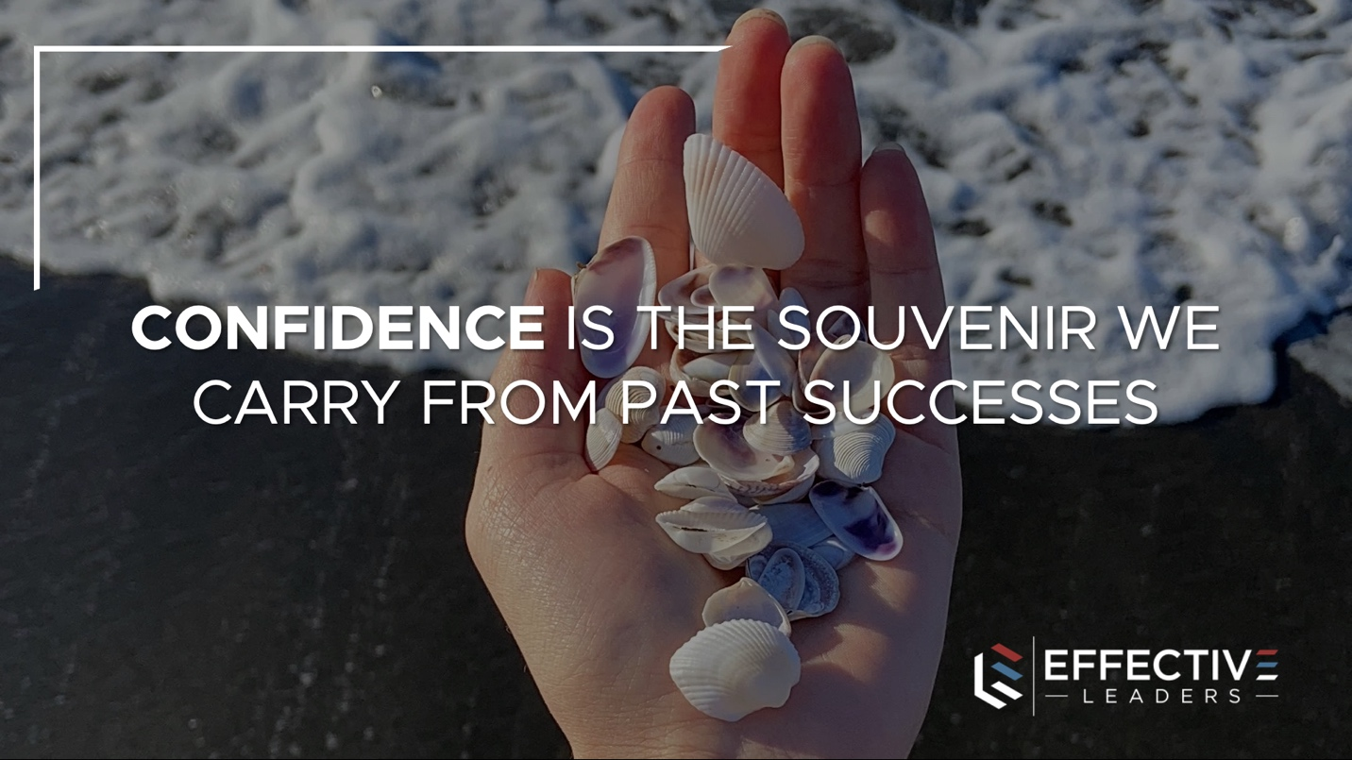

Confidence is the Souvenir We Carry from Past Successes

Past successes serve as a powerful reminder of our capabilities and strengths.

Take the time to reflect on your achievements and draw inspiration from them during moments of doubt. Each success serves as a building block, contributing to the foundation of confidence upon which future triumphs are built.

Confidence is Thinking You Can Help.

Arrogance is Thinking You Don’t Need Help.

Humility is Being Willing to Ask for Help

True confidence is grounded in humility and a willingness to seek support when needed. Recognize that leadership is not a solo endeavor and be open to leveraging the expertise and insights of others. B

y fostering a culture of collaboration and mutual support, you'll strengthen bonds within your team and empower everyone to achieve their full potential.

Believe in yourself, even when others doubt you.

All it takes is one person to see your potential and validate your confidence, so surround yourself with individuals who uplift and support you.

And as a leader, recognize opportunities to pay it forward by being that source of encouragement that inspires courage in others.

Now that you know how to build confidence as an effective leader, following the four steps above will ensure you and your team enjoy the benefits. By embracing courage, clarity, cultivation, and competence, you'll not only elevate your own leadership but also empower those around you to thrive.

- - - - -

Sean Glaze is a leadership speaker, teambuilding facilitator, and author who delivers engaging experiences that ignite your team’s performance. Sean has worked with clients like Cisco, John Deere, the CDC, and Emory University to increase collaboration, boost productivity, and build more positive and profitable workplace cultures.

As a successful basketball coach, Sean gained valuable insights on turning talent into teamwork – and now he travels around the country to share those lessons. Sean’s conference keynotes and custom team building events deliver laugh-out-loud moments and memorable take-aways that transform your people into winning teammates and more effective leaders.

Sean’s books, Rapid Teamwork, The 10 Commandments of Winning Teammates, and Staying Coachable are entertaining parables that help accelerate the growth of leaders and their teams!

