Use This Team Meeting Template to Improve Your Workplace Culture

f you are a smart leader, you understand the importance of chaving effective team meeting that does not suck.
Meetings are where your team communicates..
The quality of your communication determines how successful your team will be.
That is why we meet – whether remotely or in-person, whether daily or weekly, every team needs to share and discuss ideas that will move people forward together..
The problem is that many team meeting agenda templates suck.

A productive team meeting will always accomplish FOUR things:
1. Connection (to team mission and to team members)
2. Celebration (of what is going well, examples of values in action)
3. Contribution (invite all present to share issues and ideas)
4. Clarification (share information and define next actions to take)
If you are looking for a meeting template that doesn’t suck and that will provide your team with a structure for sharing important information, you are in the right place.
After working with teams across diverse industries for decades, I have prepared for you a downloadable team meeting template example that you can follow to ensure your people don’t suffer through something that should have been an email…
You can modify this editable team meeting word document for your organization – and I encourage you to make sure that every meeting you have from this moment forward includes ALL of the following:

1. tell participants when and where the meeting is!
Only invite people who need to know or share information at the meeting. And let them know early enough that they can prepare for and be there.

2. review your team mission statement and team norms
You need to constantly remind (at every opportunity) your team of WHY they are there and HOW they are to interact to ensure that they maintain their focus.

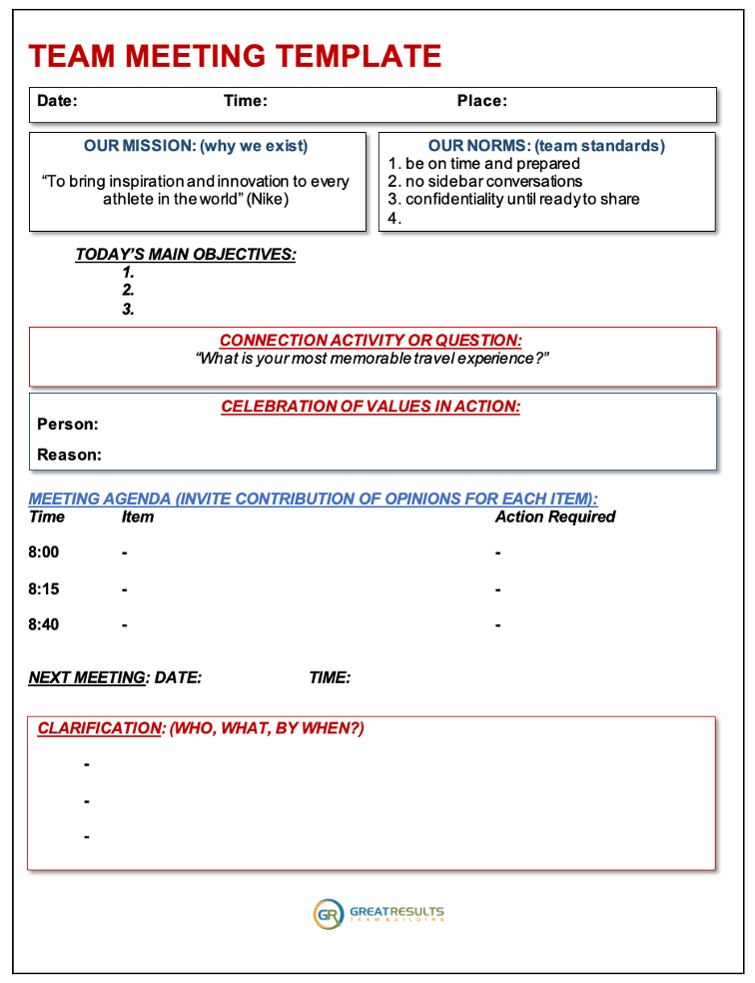

3. share the main reason you are meeting
If there is no reason to meet, then don’t. Be sure to set expectations of what will be accomplished by their attendance and contributions.

4. include an activity to build relationships
Team connections determine team productivity. There are several statistics on team building that show the impact of relationships, and taking 5-10 minutes to allow each person to answer a conversation card question will build trust and empathy.

5. include a celebration to encourage behaviors you want repeated
The values that you say are important to your organization are only defined by the behaviors that can be observed and demonstrated. What has happened recently that you can highlight to emphasize one of those values or to celebrate moving closer to a shared goal?

6. go through your meeting agenda, and invite conversations
This is the heart of your meeting, where you accomplish the daily or weekly items that must be addressed to serve your clients and coworkers. The most important part of this portion is to be sure that EVERYONE contributes in some way… Ask for input from all who are attending to make them feel valued.

7. clarify when the next meeting is and who will do what by when
Every meeting should end with commitments and action items to accomplish, that are followed up by an email or reminder to the group of what was agreed to and when they will need to meet next…
– – – – –
These seven things should be part of any team meeting template you might use.
Obviously, some teams are going to have requirements and industry-specific needs that are not included in this meeting template I have shared… but you are welcome to modify it to meet YOUR needs as a leader!
My hope is that you will incorporate each of these things into your future meeting to help build a more positive and productive team culture for your people.
Sean Glaze delivers engaging conference keynotes and interactive team building events that help healthcare and education leaders build more positive and profitable cultures.
Sean is also an author, and each of his four books, The Unexpected Leader, Rapid Teamwork, The 10 Commandments of Winning Teammates, and Staying Coachable, are entertaining parables with powerful take-aways for team growth and leadership!
What issues are YOU dealing with that would disappear if you could build a team culture that inspired connection, accountability, and a team-first attitude?

You can contact Sean at:
Sean@EffectiveLeaders.live

