**SEAN GLAZE - SHORT BIO**

Sean Glaze is a leadership and workplace culture speaker / author who delivers experiences that ignite team performance.

Sean’s engaging [conference keynotes](https://greatresultsteambuilding.net/team-building-speaker/) and custom [team building programs](https://greatresultsteambuilding.net/corporate-team-building-events/) have helped clients like Cisco, John Deere, the CDC, and Emory University to increase collaboration, boost productivity, and build [Sticky Cultures](https://stickycultures.com/) that inspire more profitable teamwork.

As a successful basketball coach, Sean gained valuable insights on turning talent into teamwork – and now he travels around the country to share those lessons. Sean’s books, [Rapid Teamwork](http://greatresultsteambuilding.net/rapid-teamwork-2/), [The 10 Commandments of Winning Teammates](http://www.winningteammate.com/), and [Staying Coachable](https://greatresultsteambuilding.net/stay-coachable/) are entertaining parables that help accelerate the growth of leaders and their teams!

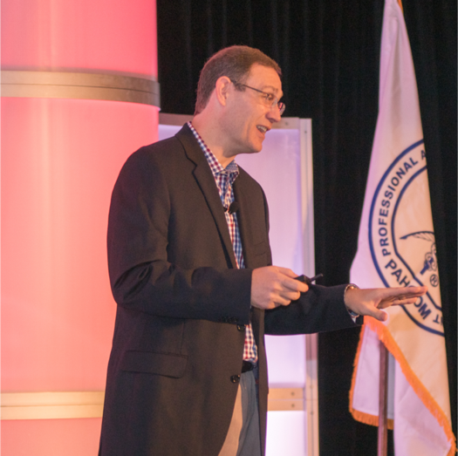 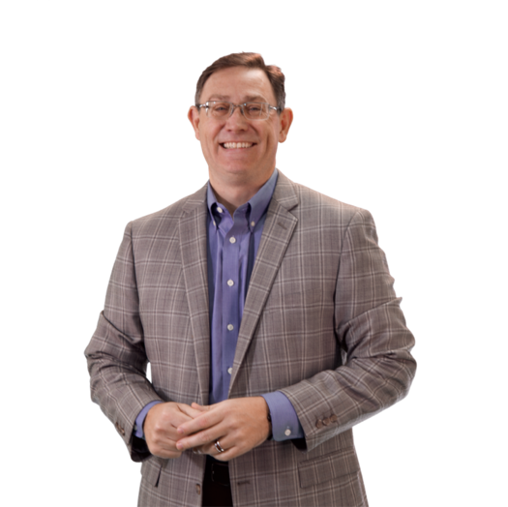 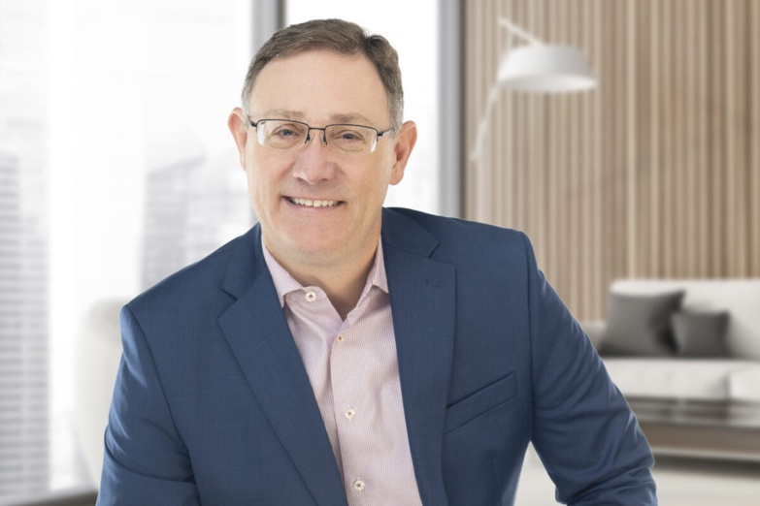

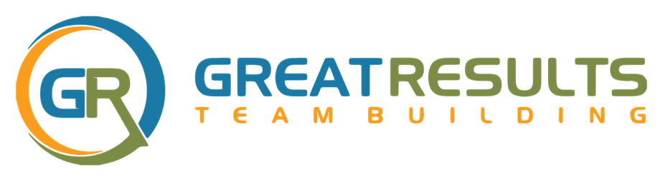

**SEAN’S SESSION TITLES AND DESCRIPTIONS**

1. ***WHAT EFFECTIVE LEADERS DO –***

***HOW TO ACCELERATE YOUR GROWTH AND IMPACT***

According to a 2022 Zippia research study, “77% of businesses report that leadership is lacking.” And while most managers want to be effective leaders, they are often promoted BEYOND their expertise.

A leader’s does not become more effective because they gain more experience or a new title. Effectiveness is about having more positive and intentional interactions as a result of increased awareness!

This engaging program is full of memorable stories and valuable content attendees can immediately implement to challenge assumptions and improve interactions within their organization. Participants will leave with tools and insights to solve problems more quickly, with the increased clarity and confidence of a process anyone can follow to have more positive impact on their team performance.

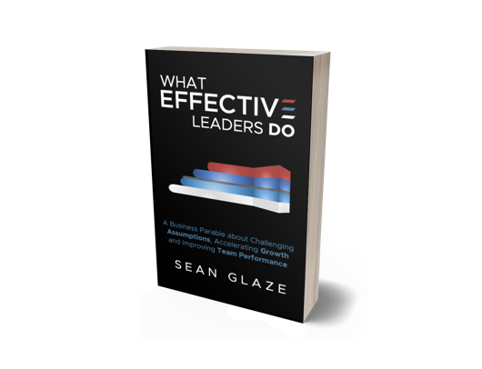

*Attendees will Discover:*

* *How CULTURE becomes evidence of your leadership*
* *One powerful shift to improve the QUESTIONS you ask*
* *The four levels of AWARENESS for problem solving*
* *How leaders evolve by prioritizing their FOCUS*
* *Two powerful BEHAVIORS to eliminate blind spots*

1. ***HOW TO BUILD A G.R.E.A.T. WORKPLACE CULTURE –***

***FIVE ESSENTIAL QUESTIONS FOR LEADERS***

In 2021, Gallup reported that “70% of a team's engagement is influenced by managers.” And while most managers want to be effective leaders, the problem is they are often unaware of the key elements required to build and sustain an exceptional team culture where people can thrive.

Session participants will learn how five essential questions can help them to identify and improve issues in their workplace culture and ensure that their people are more engaged and productive. This program includes memorable stories and valuable content you will be able to immediately implement to improve retention, boost collaboration, and ignite accountability across your organization.

Sean will equip you to be a more effective leader with the clarity and confidence of a proven, repeatable process to develop a more positive and high-performing workplace culture.

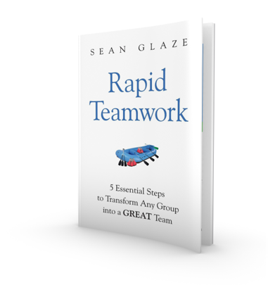

*Attendees will Discover:*

* *Why STRATEGY is not your priority as a leader*
* *The 5 essential areas of focus to build a GREAT Culture*
* *The two vital CONNECTIONS that energize a team*
* *One powerful shift to make RECOGNITION meaningful*
* *A customizable template for effective FEEDBACK conversations*

1. ***WHAT WINNING TEAMMATES DO DIFFERENTLY –***

***VITAL INSIGHTS TO IMPROVE VALUE AND INFLUENCE***

Winning, regardless of your industry, always requires more than just technical talent.

You need your team to develop interpersonal skills and awareness - because people who can build trust and focus on others most effectively will enjoy a significant competitive advantage. This program reveals the behaviors that improve organizational teamwork – and performance!

With his captivating stories, powerful content, and high-energy interaction, Sean delivers a program that inspires people to bet better teammates.

They will leave equipped to recognize the impact their behaviors have on others, take ownership of results, share appreciation, and succeed together more consistently in highly competitive and demanding environments.

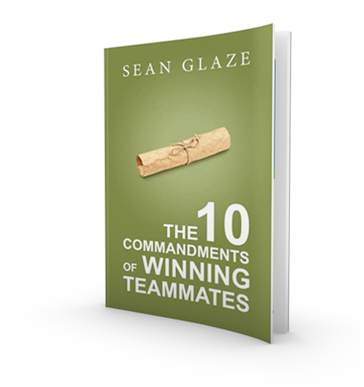

*Attendees will Discover:*

* *The three key behaviors that build and maintain TRUST*
* *One question that inspires OWNERSHIP of results*
* *How to build & strengthen meaningful RELATIONSHIPS*
* *What to do to make APPRECIATION more powerful*

1. ***STAYING COACHABLE -***

***FOUR CRUCIAL QUESTIONS TO THRIVE IN CHANGE***

Whatever business you’re in, CHANGE is part of it.

Is your team going through a merger or adopting new practices people are anxious about? Sean’s entertaining message will move your team from resistance to resilience! Are you ready to supercharge and sustain your organization’s growth?

All successful culture change starts with an internal mindset shift. This talk reveals an effective four-part process that will equip and inspire your participants to move from complacent… to committed.

With decades of coaching experience to draw from, Sean shares powerful stories and vital QUESTIONS with your audience to inspire a commitment to personal improvement.

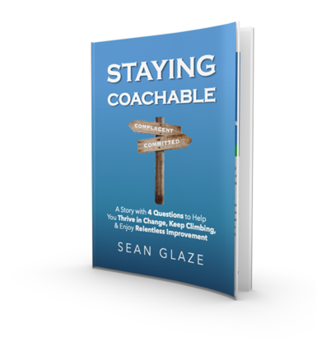

*Attendees will Discover:*

* *How to INSTANTLY transform arrogance into humility*
* *The one leadership shift that ELIMINATES resistance*
* *The FIVE dangerous words that allow complacency*
* *Four steps to make ANY merger or initiative successfully*

**SEAN’S EVENT A/V PREFERENCES**

For the best audience experience, Sean will run his program **using his own MacBook** (with embedded audio, video, and interactions) placed on a podium set to the far right or left side of the stage.

He requires the ability to advance his own slides with **his handheld remote**, and will meet at the earliest convenience of you’re a/v personnel on the event date to ensure an ideal experience.

Sean prefers a **wireless lapel or headset mic**., and requires a **digital projector with a large screen** for his program slide images and interactive polling. For audiences greater than 400 people, IMAG (image magnification) is highly recommended.

A **raised stage platform** is ideal for large audiences to ensure that all attendees have an unobstructed view of the program.

A brightly lit stage with a dark backdrop is best for audiences to maintain focus on the front of the room. Sean will utilize the entire stage and may even walk into the audience at times.

A **repeater monitor** (for power point) at front of stage is helpful.

Sean also requests **login access to the A/V Wi-Fi**.

**- - - - -**

*(Sean can accommodate his program to most any environment*

*or room and is easy to work with – please reach out if there are any questions or issues regarding room setup or a/v needs)*

**SEAN’S WEBSITE AND SOCIAL MEDIA LINKS**

**GREAT RESULTS TEAMBUILDING WEBSITE**

<https://greatresultsteambuilding.net/>

**SEAN’S RESOURE PAGE FOR EVENT PLANNERS**

<https://greatresultsteambuilding.net/resources-for-meeting-professionals/>

**SEAN ON LINKEDIN**

<https://www.linkedin.com/in/seanglaze>

**SEAN ON TWITTER**

<https://twitter.com/leadyourteam>

**SEAN ON TIKTOK**

https://www.tiktok.com/@leadyourteam

**SEAN ON FACEBOOK**

<https://www.facebook.com/GreatResultsTeambuilding?sk=wall>

**SEAN ON YOUTUBE**

<https://www.youtube.com/c/SeanGlaze>

**FOLLOW-UP RESOURCES FOR YOUR AUDIENCE -**



GET FREE ACCESS TO SEAN’S TEAM LEADERSHIP TOOLBOX,

WITH **OVER 50 USEFUL HANDOUTS & ACTIVITIES** TO

CREATE A MORE POSITIVE AND PRODUCTIVE CULTURE!

VISIT - [**WWW.TOOLBOXSTUFF.COM**](http://WWW.TOOLBOXSTUFF.COM)